A352-Asia-Vietnam-Dong Son Drum-Heger I-Bas Relief-600 BCE

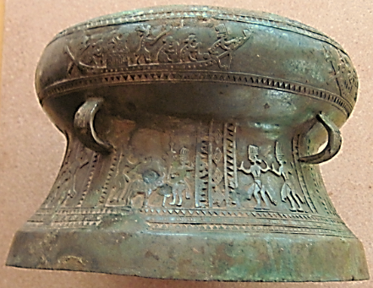

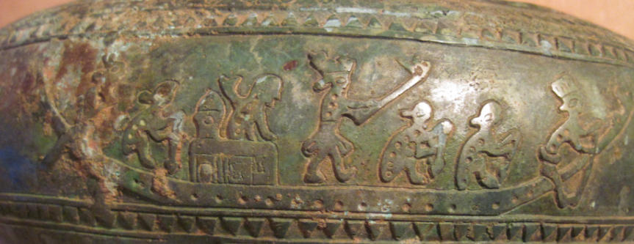

1 2 3 4 2 2 5

1. stern rudder master, 2) oarsman with pointed oar 3) Captain’s mate in bulkhead, 4) Captain with military headdress wielding a halberd, 2) 2 oarsmen, 5) prow rudder master with striped cap (belayed at waist)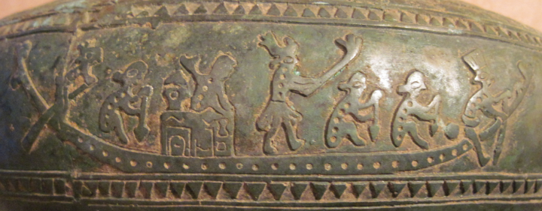 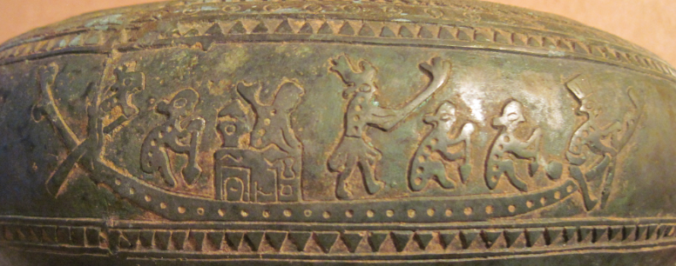 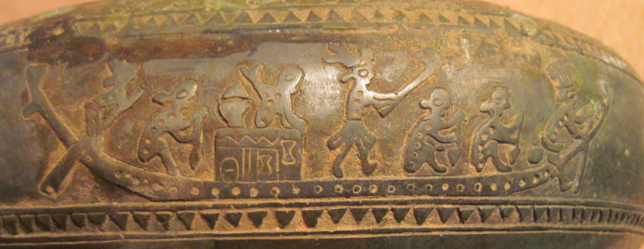

Xiaorong, Han. 1998. “The Present Echoes of the Ancient Bronze Drum: Nationalism and Archeology in Modern Vietnam and China,” *Explorations In Southeast Asian Studies, A Journal of the Southeast Asian Studies Student Association*, 2, (2 Fall).

F. Heger in 1902 in his Alte metalltrommeln aus Südost Asien collected 22 bronze drums and the records or photographs of another 143, which he divided into four types (I, II, III, IV) and three transitory types (I-II, II-IV, I-IV) based on their form, distribution, decoration, and chemical composition. He believed that Type I, found mainly in northern Vietnam was the earliest [9] so Vietnamese scholars focused their efforts on Heger's Type I. (1963, Le Van Lan, Pham) Van Kinh, and Nguyen Linh proposed to subdivide Heger's Type I according to the proportion between the diameter of the face and the height of the drum. In 1975, Nguyen Van Huyen and Hoang Vinh subdivided Heger's Type I into three subtypes. That same year, in an article published in Nhung Phat Hien Moi Ve Kao Co Hoc (New Archaeological Discoveries), Pham Van Kinh and Quang Van Cay suggested that Heger's Type I be subdivided into seven subtypes belonging to four consecutive stages.[11] Meanwhile, Tran Manh Phu,[12] as well as Luu Tran Tieu and Nguyen Minh Chuong subdivided it into four subtypes.[13] Chu Van Tan proposed two subtypes with five transitory types.[14] Diep Dinh Hoa and Pham Minh Huyen suggested seven sub-types.[15] However, the most complicated scheme was proposed by Pham Minh Huyen, Nhuyen Van Huyen and Trinh Sinh, who divided Heger's Type I into six sub-types with 24 styles.[16]

The attitude of Chinese archaeologists toward Heger's classification is sharply contrasted with that of Vietnamese scholarsFrom the 1950s to the 1980s, Chinese scholars strove continuously to make new schemes of classification (see Table 1). They made at least seven schemes during those four decades. From the 1950s to the mid 1970s, the Chinese scholars endeavored to reverse the order of Heger's first three types by categorizing the Type II as the earliest, and arguing that Heger's Type I developed from the Type II. Three out of four classifications made by Chinese scholars during that period did precisely that.[19] Only the Yunnan Provincial Museum continued to support Heger's order.[20] The above modifications of Heger's classification naturally led to much suspicion from the Vietnamese side. Vietnamese scholars were aware that China had very few of Heger's Type I bronze drums at that time, and that the great majority of Heger's Type II drums had been discovered in Guangxi, in southern China.

By the mid to late 1970s, China had discovered many bronze drums believed to belong to Heger's Type I. Moreover, after the excavation of Wanjiaba in Yunnan Province in 1975-1976, Chinese archaeologists believed that they had found the most archaic form of Heger's Type I bronze drum. As a result, they began to discard the schemes made by Chinese archaeologists in the previous period and to go back to Heger's classification. Here, however, they made one important modification: they added the newly-found Wanjiaba drums to Heger's plan as the earliest type. Wang Ningsheng,[21] Li Weiqing,[22] and Shi Zhongjian[23] represented this new, revisionist school. This revisionist school maintained the earlier Chinese view that southern China was the place of origin of the first bronze drum. Yet their works differed greatly from the previous classifications in that they took Yunnan, instead of Guangxi, as the specific place of origin of the bronze drum within southern China.

|  |  |  |  |  |  |  |  |  |  |
| --- | --- | --- | --- | --- | --- | --- | --- | --- | --- |
| http://www.beforebc.de/600_fareast/600-06-02,%20Vietnam%20drum%20from%20Dian_files/DRUMA2_1.jpg | | | | http://www.beforebc.de/600_fareast/600-06-02,%20Vietnam%20drum%20from%20Dian_files/DRUMA2_2.jpg | | | | | |
| *Figure I: Wanjiaba Drum (China)[26]* | | | | *Thuong Nong Drum (Vietnam)[27]* | | | | | |
| http://www.beforebc.de/600_fareast/600-06-02,%20Vietnam%20drum%20from%20Dian_files/DRUMA2_3.gif | | | | http://www.beforebc.de/600_fareast/600-06-02,%20Vietnam%20drum%20from%20Dian_files/DRUMA2_4.gif | | | | | |
| *Figure II: Dong Son Drum (left) and Shizhaishan Drum (right)[28]* | | | | | | | | | |
| **Table 1: Summary of Chinese Modifications on Heger's Classification** | | | | | | | | | | |
| **Author** | **Classification** | | | | | | | | **Year** | |
| Heger |  | I | | | II | | III | IV | 1902 | |
| Wen You |  | II (western) | | | I (eastern) | | III | | 1957 | |
| Yunnan Museum |  | I | II | |  | | III | IV | 1959 | |
| Huang Zengqing |  | II | | | III | I | IV | | 1964 | |
| Hong Sheng |  | III | | | II | I | IV | | 1974 | |
| Wang Ningsheng | A | B | C | | D | | F | E | 1978 | |
| Li Weiqing | I:a | I:b | I:c | | II:a | II:b | III:a | III:b | 1979 | |
| Shi Zhongjian* | 1 | 2 | 3 | 4 | 6 | 7 | 8 | 5 | 1983 | |
| ZGTY | 1 | 2 | 3 | 4 | 6 | 7 | 8 | 5 | 1988 | |
| *One way to bolster claims regarding the origins of the bronze drum was to name each type of drum after the place where it was found: a practice carried on by both Vietnamese and Chinese scholars. For example, Shi Zhongjian and the Chinese Association for Ancient Bronze Drum Studies chose the following Chinese place names to designate their eight types of bronze drum: 1. Wanjiaba (Yunnan); 2. Shizhaishan (Yunnan); 3. Lengshuichong (Guangxi); 4. Zunyi (Guizhou); 5. Majiang (Guizhou); 6. Beiliu (Guangxi); 7. Lingshan (Guangxi); 8. Ximeng (Yunnan). The conclusive volume edited by the Chinese Association for Ancient Bronze Drum Studies (ZGTY) followed Shi Zhongjian's classification. Shi was the director of the Board of Directors of the Association at the time of writing and wrote the preface to the volume. | | | | | | | | | | |

This indicated some differences between the Chinese scholars in Guangxi and their colleagues in Yunnan. These differences were not new, considering that among the four classifications made by Chinese scholars between the early 1950s and the mid-1970s, only the one made by the Yunnan Provincial Museum refused to recongnize Heger's Type II, found mostly in Guangxi, as the earliest bronze drum. It was probably not a coincidence that two of the three scholars who claimed the Guangxi origin of the bronze drum, Huang Zengqing and Hong Sheng, were from Guangxi (the other, Wen You,[24] hailed from Sichuan). Incidentally, two of the scholars who claimed the Yunnan origin of the bronze drum, Wang Ningsheng and Li Weiqing, were from Yunnan (the other, Shi Zhongjian, from Beijing). It was reported in 1982, however, that a majority of Chinese archaeologists had agreed that the bronze drum originated in Yunnan.[25] This implied that there was still a minority that did not agree. The debate with Vietnamese scholars had probably prevented this minority from expressing their views. By 1995, Chinese archaeologists had all agreed that the Wanjiaba type bronze drum was the earliest and that Chuxiong prefecture in Yunnan, where Wanjiaba is located, was thus the birth place of the bronze drum.[26]

Figure 2: Wanjiaba Drum (China)[27]

|  |
| --- |
| http://www.beforebc.de/600_fareast/600-06-02,%20Vietnam%20drum%20from%20Dian_files/DRUMA2_1.jpg |
| *Figure I: Wanjiaba Drum (China)[26]* |

**Fig 7**

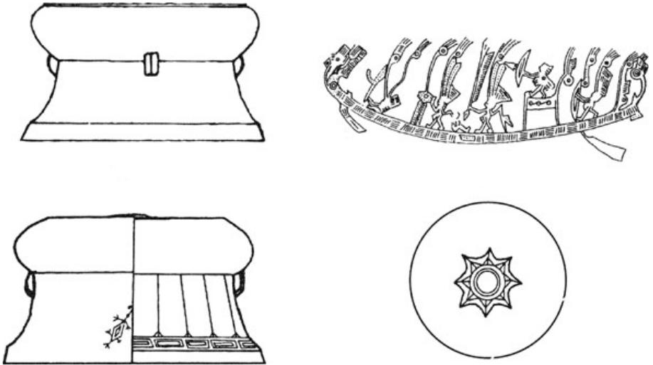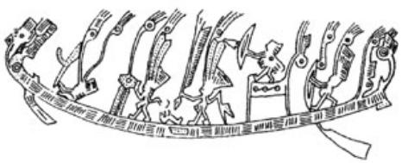

The typological differences characterizing Wanjiaba- and Shizhaishan-style drums. The body of the Shizhaishan drum (top left) is typically decorated with warriors wearing feathered headdress rowing a boat (top right) (redrawn from Higham 2002, p. 179). The body of the Wanjiaba drum (bottom left) is decorated with spiny figures (redrawn from Li and Huang 2007, Fig. 4); the drum face has a raised sunburst pattern (bottom right)

## Extracts from the Article What's this?



Another defining feature in the eastern area of the Yunnan-Guizhou Plateau is the use of large bronze drums, referred to in the archaeological literature as Heger I or Shizhaishan type (Fig. 7).



Unlike the Shizhaishan drums, Wanjiaba drums have limited adornment on the vessel body beyond the sunburst pattern on the drum face and isolated spiny figures on the shoulder (Fig. 7) (Zhang 1993, p.

Vietnamese scholars claimed that the attempts by Chinese archaeologists to reclassify the bronze drums were all groundless. They argued that besides the fact that China had very few of Heger's Type I drums, the Chinese had reversed the order of Heger's first three types before the mid-1970s because they believed that the bronze culture in the south could not have developed without the influence of Chinese culture from the north. Heger's Type II, the Vietnamese noted, had something which the Chinese were looking for: decorations similar to those found in the Central Plain area of China. These classifications, just like the traditional Chinese belief that the bronze drum had been invented by Ma Yuan---the Han general who crushed the Trung sisters' rebellion in Vietnam in 40 CE---and Zhuge Liang---the famous prime minister of the state of Shu during the Three Kingdoms period (220-265 CE)[28]---reflected the mentality of Han chauvinism. To Vietnamese scholars, Chinese classification schemes were not reflective of historical realities, but precisely the opposite, constructions of the present.[29]

The more recent Chinese classifications, which returned to, but adapted, Heger's plan to include the Wanjiaba drums as the earliest type, were based in part on the idea that the form and decoration of the Wanjiaba drums were very simple: the premise being that the simpler the form and decoration, the more ancient the drum. Vietnamese scholars believed that this was another misinterpretation. The three principles used by Chinese scholars in their classification---namely that "the face of the drum grew bigger and bigger, the body of the drum decreased from three to two parts, and the decorations became more and more complex"---were considered to be oversimplifications by Vietnamese scholars. They argued that the simple form and decorations could also be indications of decline, thereby implying that the Wanjiaba drum was not the earliest of the various types of bronze drum, but the latest.[30] Phan Huy Thong was a Vietnamese scholar who argued this point. According to him, drums of the same type were found in Vietnam during the 1930s and had long since been judged to be coarse, but late.[31] Thus, in the most complicated Vietnamese classification proposed in the publication Trong Dong Son (The Dong Son Drum), the Wanjiaba Drum was listed as the fourth sub-type of the Dong Son Drum (Heger's Type I). The Thuong Nong drum, a Wanjiaba style bronze drum found in Vietnam in the 1980s, was put in the same sub-type (see Figure 3).

Figure 3: Thuong Nong Drum (Vietnam)[32]

The aim of all of these classifications was to determine the relative dating of the bronze drums. To date, scholars in the two countries have not found common ground on this issue. The biggest problem concerns the first two types of Heger's classification, which are directly linked to the issue of the origins of the bronze drum. Since relative dating proved unconvincing to both sides, Chinese and Vietnamese scholars then made attempts at absolute dating. However, this proved to be as controversial as relative dating.

The Vietnamese scholar Vu Tang proclaimed in 1974 that he dated one bronze drum to the 13th-10th centuries BCE and another one to the beginning of the late second millenium BCE. This is the earliest absolute dating so far proclaimed for any bronze drum by any scholar. However, this dating later led to much criticism from Chinese scholars, according to whom the method used to date those two drums had been unscientific.[33] The dating of the first drum was based on the motifs of rings and parallel lines, which are believed to be similar to those found on ceramics of that period of time. Apparently, Vietnamese scholars later discarded this dating scheme, as it was not included in Trong Dong Son (The Dong Son Drum), the conclusive volume published in 1987.

Other Vietnamese scholars believed that the earliest Dong Son drum can be dated alternately to the 7th century BCE;[34] or the 8th century BCE;[35] or sometime before the 7th century BCE.[36] Vietnamese scholars later admitted that it was difficult to reach an exact date for the Dong Son drum because many drums were discovered accidentally, and thus, the sites were not well protected. Further, it is very difficult to find any biological materials directly related to the drum which may be useful in arriving at an absolute date.[37]

The earliest C14 date established for a bronze drum excavated in China by Chinese scholars is 2640+- 90 before 1950, or 690 +- 90 BCE.[38] The dating was based on the materials that coexisted with the drum in the tombs. Chinese scholars claimed that this is the earliest credible C14 dating for any bronze drum. They argued that the Wanjiaba type bronze drums were mostly made between the 7th and 5th centuries BCE, and that the Shizhaishan (or Dong Son) type was popular between the 6th century BCE and the 1st century CE: the latter representing a more developed form of the former.[39]

However, according to Vietnamese scholars, this dating is erroneous. Vietnamese archaeologists conducted an experiment on a piece of wood obtained from an excavated coffin and found that the margin of error for such dating could be as much as 235 years. They believed that the Chinese archaeologists deliberately chose that date in order to support their claim of the southern China origin of the bronze drum. According to Vietnamese scholars, the dating of bronze drums should not be based solely on C14 statistics. Instead, other factors should also be taken into consideration. They even went so far as to set an example for the Chinese. A bronze drum was found in an ancient tomb at Viet Khe. C14 dating indicated that the tomb was from 2480+-100 years before 1950 CE, or around 530 BCE.[40] However, based on its style, it was decided that the drum could only be dated to the 3rd or 4th centuries BCE. To date, scholars from the two countries have failed to reach common ground regarding absolute dating, just as they have not achieved a consensus on relative dating.

#### Interpretation of the Decoration

The decoration of the bronze drum is another major field of controversy between Vietnamese and Chinese scholars. Decoration is important because it is believed to reflect the social and spiritual life of the people who invented and used the drum and, thus, can help determine its ethnic and geographical affiliations. The most popular motifs on the early drums (Heger's first two types plus the Wanjiaba) include various species of birds and other animals, as well as boats, shining entities, and geometrical lines.

A flying bird with a long beak and long feet appeared very frequently on the early drums, and a good deal of scholarly attention was devoted toward trying to determine what kind of bird it was (see Figure 4).[41] Dao Duy Anh, the Vietnamese historian, believed that it was the legendary "lac bird," the symbol of the ancient Viet people. Dao Tu Khai, however, argued that the bird was not a lac bird because the lac bird was a magpie or some other species whose appearance was rather different from that of the bird on the bronze drum. According to Dao Thu Khai, the bird was, instead, a heron.[42] Still other scholars argued that the lac bird and the heron were the same.[43] What is more, it was argued that herons lived in every part of Vietnam, and the ancient Viet people regarded them as the symbol of the laborious peasants because it was believed to be diligent. As one Vietnamese scholar put it, "We believe that since the bronze drum is a product of Vietnam made by the Viet people, it should reflect something real in the Vietnamese landscape. The flying bird on bronze drums should be something that the Viet people were very familiar with, and it should have a Vietnamese name. We believe that our interpretation of the bird with its long beak and long feet on bronze drums as a heron is in conformity with the reality of Vietnamese history and culture."[44]

Figure 4: Flying Birds on Bronze Drums[45]

Most Chinese scholars also believe that the bird is a heron. However, they do not agree that the heron is a symbol of the ancient Vietnamese peasants. Instead, they interpret it more as a result of Chinese influence. They argued that the heron is considered to be the spirit of the drum in the Central Plain of China. This belief first spread to the Chu area in southern China and then reached other ethnic groups living to the south of Chu. According to the Chinese Association of Bronze Drum Studies,

The flying heron is the major motif on Shizhaishan drums (Dong Son drums). There is a long tradition of decorating drums with the motif of herons in the Central Plain. The feather drums excavated from the Chu tombs in Xinyang, Henan and Jiangling, Hubei and the Zenghouyi tomb in Suixian, Hubei are all decorated with the motif of the heron...there is clear evidence to support the idea that the motif of the flying heron on the Shizhaishan drums originated in the Chu area.[46]

In addition to the bird motifs, there are also small three-dimentional animals on the face of some Dong Son (Shizhaishan) drums and other types of drums which archaeologists have argued are either frogs or toads (see Figure 5). Chinese scholars argued that they were frogs and explained them as decorations without special meaning,[47] or something related to the ceremony of rain-seeking, or the frog-worshipping custom of the ancient Yue people of southern China, a group believed to be related to the ancient Viet people.[48] Edward Schafer agreed that the animals were frogs, "for the drum embodied a frog spirit---that is a spirit of water and rain---and its voice was the booming rumble of the bullfrog." He retold a story of the Tang period recorded in a Chinese source to show that the drum could even take the form of a living frog. According to the story, a frog pursued by a person leaped into a hole, which turned out to be the grave of a Man (barbarian) chieftain containing a bronze drum with a rich green patina, covered with batrachian figures. The bronze drum was believed to be the reincarnation of the frog.[49] Vietnamese scholars initially agreed that the animals were frogs in the 1970s,[50] but later interpreted them as toads because "a widely known popular saying in Vietnam calls the toad 'the uncle of the heavenly god' and maintains that rain will inevitably fall when the toad raises his head and croaks."[51]

Figure 5: Frogs or Toads on a Dong Son drum[52]

The motif of a long boat is another very popular decoration on the surface of the Dong Son (or Shizhaishan) drums (see Figure 6). Usually the two ends of the boat are decorated with the head and tail of a bird. In the boat are numerous ornamented human figures. There are fish under the boat and birds around the boat. Following Goloubew, Dao Duy Anh believed this was the "golden boat" described in the belief system of the Dayak people of Kalimantan in Indonesia that carries the spirits of dead people, symbolized by the birds, to heaven. He further concluded that there was a possible blood relationship between the Dayaks and the Lac Viet, and that the ancient Lac Viet could be the ancestors of the Dayaks.[53]

Figure 6: Boats on bronze drums[54]

Feng Hanji, a Chinese archaeologist, did not agree. He believed the motif of the long boat was a reflection of the popular custom of boat racing in southern China. According to Feng, the boat does not have an outrigger, thus, it could only have been used in rivers or small inner waters like the Dian Lake. Further, to decorate boats with birds was also an old tradition in China. He also believed that the motif might indicate some connections with the Chu.[55] Ling Shunsheng, a Chinese ethnologist, wrote in 1950 that the motif of the long boat was a direct reflection of the custom of boat racing in ancient Chu. Although legend has it that the custom was to pay tribute to the memory of Qu Yuan, a Chu poet from the 3rd century BCE, Ling argued that the custom had an even earlier origin.[56] Chinese scholars later pointed out that the boats on bronze drums were involved in four different kinds of activities which were all popular in ancient southern China, namely, fishing, navigating, boat racing, and offering sacrifices to the spirits of the river.[57]

Vietnamese scholars later accepted the idea that the motif was about boat racing. However, they interpreted it as a part of the ancient Viet ceremony for seeking rain and water.[58]

As for the shining entity located in the center of the surface of bronze drums, some scholars have interpreted this as a star, while others have viewed it as the sun (see Figure 7). Vietnamese scholars have taken the position that this reflects the ancient Viet custom of worshipping the sun.[59] Meanwhile, Chinese scholars have argued that many ancient ethnic groups in China, such as the Shang (or Yin), the Chu, and other southern peoples, all worshipped the sun. Moreover, rulers tended to use the sun as a symbol of themselves.[60]

Figure 7: Shining Entities on Bronze Drums[61]

The two most common geometric motiffs on bronze drums are believed to represent clouds and thunder. According to Chinese scholars, the same motifs can be found on the ancient carved-motif pottery of southern China, as well as the bronze wares of the Central Plain. The motifs, it was argued in the Zhongguo Gudai Tonggu, "prove the uniformity and continuity of the cultural development of ancient southern China and the frequent cultural exchange between southern China and the Central Plain."[62] They also reflect the custom of worshipping clouds and thunder in ancient China. These motifs appear only occasionally on Dong Son drums but can be frequently seen on Heger's Type II drums, most of which have been found in southern China especially the Guangxi Zhuang Autonomous Region. Vietnamese scholars did not openly object to the Chinese claim that such motifs reflect Chinese influence; however, they strongly rejected the idea that such an influence proves that the bronze culture of the south developed under Chinese influence and that drums bearing such motifs are the most ancient.[63]

In sum, Vietnamese scholars tend to view the decorations of early bronze drums, especially the Dong Son drums, as a reflection of the special cultural characteristics of the ancient Viet people. They believe that the various motifs on the bronze drum describe the various aspects of the life of the ancient agrarian Viet culture of the Dong Son age.[64] They, therfore, argue that the decorations prove that the Dong Son drum belonged to the ancient Viet people. However, Chinese scholars interpret the decorations as a reflection of the cultural exchange between interior China and China's frontier, arguing that they represent the cultural features of the various peoples living in that area, and not just the Lac Viet. They do not deny the affiliation between the Dong Son drum and the Lac Viet, but they believe the same type of drum was also used by other ancient ethnic groups---such as the Dian, the Laojin, the Mimo, the Yelang and the Juding---believed to be the relatives of the Lac Viet. They thus contend that the earliest type drum was invented in a region belonging to modern China. According to them, "the Dong Son drum is a developed form of the imported Chinese Shizhaishan drum, which spread from Yunnan to Vietnam along the Red River."[65] Citing both historical records and archaeological findings, Chinese scholars have tried to prove that the earliest drum was invented by the Pu-Liao groups which included the Dian from the Dian Lake area of Yunnan, the Yeyu and Mifei of the Chuxiong and Erhai areas of Yunnan, the Yelang and Juding of western Guizhou, and the Qiongdu of southwestern Sichuan. According to Chinese scholars, the bronze drum was first invented by the Pu-Liao people on the eastern Yunnan plateau and then spread to the surrounding areas.[66] Chinese scholars have proposed that the Lac Viet also belonged to this Pu-Liao group and have cited the similarities between the Dian culture in Yunnan and the Dong Son culture of Vietnam as evidence.[67]

#### Nationalism and the Bronze Drum

The functions and the molding methods of the bronze drum also caused much controversy. However, these issues are less related to the origins of the bronze drum and, hence, differences on such issues have been more individual than national. Only in regards to issues that are more relevant to the ethnic and geographical origins of the bronze drum, such as its classification, dating and the interpretation of the decorations, can a clear national difference be discerned. In fact, the issue of the origin of the bronze drum came to resemble a sacred topic in both countries. The scholars in each country debated freely among themselves about many details. For example, there are Vietnamese scholars who support the Chinese claim that the flying bird is a heron, and Chinese scholars who believe that the bird is the totem of the Lac people.[68] However, once the debate touched on the key issue of origin, all scholars took a national stand. Therefore, the Vietnamese scholars who support the heron interpretation do not believe that there is a connection between the heron and the Chinese spirit of the drum, while the Chinese scholars following the Lac bird explanation do not think it has anything to do with the Vietnamese origin of the bronze drum. Hence, they have quarreled freely about the smaller details, but no one has dared to challenge the larger conclusions.

The origin of the bronze drum was deemed important by scholars in China and Vietnam during this period of time not only because of its academic significance, but also because of its political value, the latter probably outweighing the former. To the Chinese and Vietnamese scholars, the bronze drum was not just an archaeological artifact, but, more importantly, a crucial part of their national culture and national identity. The sound of the ancient bronze drum stimulated the modern nationalistic nerves of the archaeologists.

Communist victory in China and Vietnam brought about a process of reconstructing history which was in both countries guided by the two important principles of Marxism and nationalism. The research of sensitive topics concerning the past relationship between the two countries, such as the issue of the bronze drum, was always permeated by a strong nationalistic spirit. When the two countries enjoyed "comradeship plus brotherhood" (in Chinese, "Tongzhi jia xiongdi") from the 1950s to the mid 1970s, that spirit was covered with a Marxist Internationalist coating. Hence, the Vietnamese and Chinese scholars made their own nationalistic claims but never openly accused each other. For example, both Wen You and Dao Duy Anh published their works in the 1950s, Wen was the first Chinese scholar to attempt to modify Heger's classification to propose a China origin of the bronze drum, while Dao made the claim that the bronze drum was invented by the Lac Viet and then spread to some minority areas of Vietnam, southern China, and insular Southeast Asia. Their works went unnoticed for about two decades. It was not until the late 1970s that they were accused of mixing academic work with chauvinist or nationalistic agendas. The break-down of Sino-Vietnamese bilateral relations in the late 1970s brought nationalism to the fore in both countries, thereby overriding the internationalism of the previous years.

For Vietnamese scholars, an essential part of reconstructing Vietnamese history was to prove the existence of the legendary Van Lang state established by the Hung Kings. This itself was in turn part of a larger program to prove that the Red River delta was an early center of civilization independent of the north. Their starting point was to establish a direct relationship between the Hung Kings and Dong Son culture, and then to prove that the Dong Son culture was native to northern Vietnam. To do so, they had to prove the native origin of the bronze drum because it is one of the most important artifacts of the Dong Son culture. Pham Huy Thong, who wrote the prefaces to the two special issues on bronze drums in the journal Khao Co Hoc (Archaeology) writes:

In our process of studying the dawn of human history, namely, the age of the Hung Kings, the artifact that has gradually emerged as the most deserving symbol of the Hung Kings civilization is the bronze drum. More accurately speaking, it is the Type I drum among the four types classified by Heger in the beginning of this century.[69]

In his work on bronze drums published posthumously in 1990, he declared that "the Dong son drums were cast on Vietnamese soil by the bearers of the Dong Son culture at the time of state formation. They were the handiwork of the forebears of the present-day Vietnamese, the ancient Viet state builders who were conscious of their ethnic and cultural identity."[70] According to Pham, the idea that the bronze drum was an original and typical artifact of the Dong Son culture was first brought up in the four-volume collective historical work Hung Vuong Duong Nuoc (The Founding of the State by the Hung Kings). Published between 1969 and 1971, it was to become the foundation on which all further studies of the Dong Son culture were based.[71] A later book about how the Hung Kings built the Vietnamese nation has a picture of a bronze drum on its cover and lists the bronze drum as the most typical artifact of the Dong Son culture.[72]

For Chinese archaeologists, bronze drums served different purposes at different times. For the older generation of Chinese scholars like Luo Xianglin and Xu Songshi, not only the Han Chinese, but also the various ethnic groups in southern China, were all considered to be branches of the larger Han Chinese race. They supported Sun Yat-sen's claim that China had only five ethnic groups, namely, Han, Hui (Muslims), Manchus, Mongols, and Tibetans. That classification included most ethnic minorities in southern China in the Han group.[73] Both Luo and Xu were southerners themselves. To them, the bronze drum served as an indicator of the cultural achievement of the southern Chinese as well as a symbol of southern identity. After 1949, the Chinese government officially identified many southern groups as ethnic minorities independent of the Han. It encouraged scholars to prove that the minority peoples had their own cultural achievements, but also that historically there had been much mutual influence between the Han Chinese and the Southern minorities. As a result, the bronze drum, which was scorned by earlier Chinese scholars because of its "barbarian" origins,[74] was now regarded as one of the most magnificent material relics of the southern minority peoples and the symbol of interior/frontier cultural exchange. The Chinese archaeologist Wen You wrote, "If somebody asks, what is the most important ancient cultural relic of our minority siblings in southern China, we can answer him unhesitatingly that it is the bronze drum." The bronze drum, he further claimed, was the "common treasure of all the people of China."[75] The two authors of an article about the ethnic affiliations of the various types of bronze drum concluded that their study "reflects in a specific aspect the process of ethnic mixture and cultural exchange among the brotherly ethnic groups of China," and "sufficiently proves that the various ethnic groups in southern China, together with other ethnic groups of China, created the great, brillant ancient culture of the Chinese nation."[76] Such expressions are very common among Chinese archaeologists. Moreover, such research might also be related to the construction of local identities and the expressions of local pride, as evidenced by the subtle differences between the Guangxi and Yunnan scholars on the issue of the origins of the bronze drum.

The core issue is that both Vietnamese and Chinese scholars try to make exclusive claims to a tradition that was possibly shared by the ancestors of both the Vietnamese and the minority peoples of southern China. There was no boundary between southern China and northern Vietnam at the time the bronze drum was invented. Many of the groups living in that vast area were interrelated either biologically, culturally, or both. The people who invented the bronze drum would have had no consciousness of polities such as "Vietnam" or "China," as we do today. It is unfair to impose such modern concepts on ancient peoples and to determine exactly when, where, and who invented the bronze drum. Charles Higham, an outsider to these disputes, commented that the nationalistic bias of the Vietnamese and Chinese archaeologists had obscured the situation revealed by archaeology. He hypothesized that the bronze drum was created by the specialized artisans of a cluster of increasingly complex polities that spread across the present day Sino-Vietnamese border to arm the warriors of their polities and signal the high status of their leaders. He concludes,

Seeking the origins of this trend and the associated changes in material culture in one or other particular region misses the point. Changes were taking place across much of what is now southern China and the lower Red River Valley by groups which were exchanging goods and ideas, and responding to the expansion from the north of an aggressive, powerful state.[77]

Hence, the theme of the bronze drum could equally make for an excellent story about the cultural coprosperity and unity of the various peoples living in that area.

It is interesting to note that in order to prove the indigenous origins of the bronze drum (in either southern China or northern Vietnam), both Vietnamese and Chinese scholars have vehemently denied any possibility of a place of origin outside of the present-day southern China and northern Vietnam landmass. J.D.E. Schmeltz's (1896) theory about the Indian origin of the bronze drum, A.B. Meyer and W. Foy's (1897) theory about the Cambodian origin and R.Heine-Geldern's (1937) theory about the European origins of the Dong Son culture have all been criticised by both Vietnamese and Chinese scholars.[78] In fact, this is probably the only significant common ground for scholars from the two countries about the origin of the bronze drum.

The obscurity of the information about the bronze drum is an important element in the whole debate. There are no inscriptions on the bronze drums. The records in Chinese classics about the origins of the bronze drum are not supported by solid evidence and are often contradictory. Modern techniques have also failed to provide hard evidence about its origin. As a result, neither side has been able to persuade the other. All conclusions made about the origin of the bronze drum are more or less speculations, which are the result of limited archaeological information and nationalistic sentiment. In other words, the bronze drum is an artifact ambiguous enough for both sides to render some meaningful interpretation for themselves. The same ambiguity makes it difficult for an outsider to determine who is right and who is wrong.

Largely as a result of improved Sino-Vietnamese bilateral relations, the crossfire between Chinese and Vietnamese scholars over issues surrounding bronze drums has come to an end. However, neither side has changed its stand. They have just set the topic aside or have made their own claims from time to time without openly accusing the opposite side, a situation similar to that which prevailed in the 1950s and 1960s. The issue has become less important but remains unresolved, and it will probably reemerge under new circumstances. There may be more academic exchanges between Chinese and Vietnamese scholars in the future and more research on other aspects of the bronze drum may take place as well. However, the views on the origins of the bronze drum held by each respective side are not likely to change in the near future. This intransigence is the result of a tradition that has existed in the two countries for a long time: a tradition of making official history and using the past to serve the present.

### Notes

1 Zhongguo Gudai Tonggu Yanjiuhui, Zhongguo gudai tonggu (The Ancient Bronze Drums of China) (Beijing: Wenwu Press, 1988), 8. Hereafter, ZGTY. According to this book, the numbers of bronze drums stored in various provinces and cities are as follows: Guangxi: 560; Guangdong: 230; Shanghai: 230; Yunnan: 160; Guizhou: 88; Beijing: 84; Sichuan:51; Hunan: 27; Shandong: 8; Hubei: 6; Zhejiang: 6; Liaoning: 4. The total number of bronze drums stored in China remained unchanged in 1995. See Shijie ribao (World Journal), "Nanfang tonggu wenhua yanjiu you chengguo" (Results have been achieved in the Study of the bronze drums of southern China), 13 January 1995, 11.

2 Nguyen Duy Hinh, "Bronze Drums in Vietnam," The Vietnam Forum 9 (1987): 4-5; Pham Huy Thong, Dong Son Drums in Vietnam, (Hanoi: The Vietnam Social Science Publishing House, 1990), 265. Some more Dong Son drums have been found in Vietnam since then. For example, in 1994, a Dong Son drum later named a Ban Khooc drum was found in Son La Province in northwestern Vietnam. Pham Quoc Quan and Nguyen Van Doan, "Trong Dong Son La" (The Son La Bronze Drum), Khao Co Hoc 1 (1996): 10.

3 Xu Songshi, Baiyue xiongfeng lingnan tonggu (The Masculine Spirit of the Hundred-Yue and the Bronze Drums of Southern China), Asian Folklore & Social Life Monographs 95 (Taibei: The Orient Cultural Service, 1977), 7-8.

4 Nguyen Duy Hinh, "Trong dong trong su sach" (The Bronze Drums in Historical Records), Khao Co Hoc 13 (1974): 18-20.

5 Jiang Tingyu, Tonggu shihua (History of the Bronze Drum) (Beijing, Wen Wu Press, 1982), 18.

6 For a comprehensive introduction to and list of Western archaeological works on the bronze drum see Pham Minh Huyen, Nguyen Van Huyen and Trinh Sinh, Trong Dong Son (The Dong Son Drums) (Hanoi: Nha Xuat Ban Khoa Hoc Xa Hoi, 1987), 12-14, 306-309; ZGTY, 10-12.

7 Wenwu Bianji Weiyuanhui (Editorial Board of Cultural Relics), Wenwu kaogu gongzuo shinian: 1979-1989 (A Decade of Work in the Field of Cultural Relics and Archaeology: 1979-1989) (Beijing, Wenwu Press, 1990), 376, 380.

8 Pham, Nguyen and Trinh.

9 Pham, Nguyen and Trinh, 19-21; ZGTY, 10-11.

10 Pham Huy Thong, Dong Son Drums in Vietnam,, 4.

11 Pham, Nguyen and Trinh, 21-22.

12 Tran Manh Phu, "Thu chia nhom nhung trong dong loai I Hego phat hien o Viet Nam" (The Classification of Heger's Type I Bronze Drums Discovered in Vietnam), Khao Co Hoc 13 (1974): 83-94.

13 Luu Tran Tieu and Nguyen Minh Chuong, "Nien dai trong Dong Son" (The Dating of the Dong Son Drums), Khao Co Hoc 13 (1974): 117-121.

14 Chu Van Tan, "Nien dai trong Dong Son" (The Dating of the Dong Son Drum), Khao Co Hoc 13 (1974): 106-116.

15 Diep Dinh Hoa and Pham Minh Huyen, "Ve viec chia loai trong loai I Hego va moi quan he giua loai trong nay voi cac loai trong khac" (The Classification of Heger's Type I Bronze Drums and Its Relationship with Other Types of Bronze Drum), Khao Co Hoc 13 (1974): 126-134.

16 Pham, Nguyen and Trinh, 23-34, 120-123.

17 For example, Heger's Type II were mostly found in southern China and among the Muong minority of Vietnam; Type III existed in Burma and southern China but not in Vietnam; Type IV were believed to exist in southern China only. Pham Huy Thong, "Trong Dong" (The Bronze Drum), Khao Co Hoc 13(1974): 9-11. It was reported in the 1980s that 14 Type III drums and 6 Type IV drums had been found in Vietnam. Nguyen Duy Hinh, 4.

18 ZGTY, 12.

19 Wen You, Gu tonggu tulu (Collected Pictures of the Ancient Bronze Drums) (Beijing: Zhongguo gudian yishu Press, 1957), n.p.; Huang Zengqing, "Guangxi tonggu chutan" (The Bronze Drums of Guangxi), Kaogu 11 (1964), 578-588; Hong Sheng, "Guangxi gudai tonggu yanjiu" (The Ancient Bronze Drums in Guangxi), Kaogu Xuebao 1 (1974): 45-90.

20 Li Weiqing, "Zhongguo nanfang tonggu de fenlei he duandai" (The Classification and Dating of the Bronze Drums of Southern China), Kaogu 1 (1979): 66-78.

21 Wang Ningsheng, "Shilun zhongguo gudai tonggu" (On the Ancient Bronze Drums of China), in Minzu kaoguxue lunji (Collected Eaasys on Ethnoarchaeology) (Beijing: Wenwu Press, 1989), 277-306.

22 Li Weiqing, 66-78.

23 Shi Zhongjian, "Ancient Bronze Drums," China Pictorial 10 (1983): 24-25.

24 Wen You worked in Sichuan as a University professor for more than ten years before he moved to Beijing in the mid-1950s. He wrote in 1956 that he first became interested in the bronze drum when he saw a beautiful bronze drum in Hanoi more than a decade earlier. Wen You, preface.

25 Shi Zhongjian, "Shizheng Yue yu Luoyue chuzi tongyuan" (On the Common Origin of the Yue [Viet] and Luoyue [Lac Viet)], in Baiyue minzushi lunji, (Beijing: China Social Science Press, 1982), 203.

26 Shijie ribao, 13 January 1995, 11.

27 ZGTY, Plate IX.

28 Fan Chengda, a scholar-official of the Song Dynasty (960-1279 AD) first suggested that the bronze drum was invented by Ma Yuan. A scholar in the Ming dynasty (1368-1644) first recorded that the big bronze drum was invented by Ma Yuan, and the small one by Zhuge Liang. F. Hirth tried to prove these stories in two articles published in 1898 and 1904. Zheng Shixu (Cheng Shih-hsu), Tonggu kaolue (A Study of the Bronze Drum) (Shanghai: Shanghai Museum, 1936), 3-5, 14, 33-37.

29 Nguyen Duy Hinh, "Ve guan diem cua mot so hoc gia Trung Quoc nghien cuu trong dong nguoi Viet" (A Review of the Views of Some Chinese Scholars on the Bronze Drums of the Vietnamese People), Khao Co Hoc 4 (1979): 17-19.

30 Nguyen Duy Hinh, "Ve guan diem," 21; Chu Van Tan, "Phai chang ho da tim thay trong X?" (Have They Discovered Drum X?), Khao Co Hoc 9 (1982): 33.

31 Pham Huy Thong, Dong Son Drums in Vietnam, 269.

32 Pham Huy Thong, Dong Son Drums in Vietnam, 210.

33 Tong Enzheng, "Shilun zaoqi tonggu" (On the Early Bronze Drums), in Zhongguo xinan minzu kaogu lunwenji (Collected Essays on the Ethnoarchaeology of Southwestern China) (Beijing: Wenwu Press, 1990), 163-185.

34 Nyuyen Van Huyen, "Tu chia loai nhom den tim hieu nien dai va que huong cua trong dong co" (From the Classification and Sub-classification of the Ancient Bronze Drums to the Understanding of their Dating and Origins), Khao Co Hoc 13 (1974), 101; Chu Van Tan, "Nien dai trong Dong Son," 114.

35 Diep Dinh Hoa and Pham Minh Huyen, 131.

36 Luu Tran Tieu and Nguyen Minh Chuong, 119.

37 Pham, Nguyen and Trinh, 216-217.

38 ZGTY, 110.

39 Wang Dadao, "Yunnan qingtong wenhua jichi yu Yuenan Dongshan wenhua, Taiguo Banching wenhua de guanxi" (The Bronze Culture of Yunnan and its relations with the Dong Son Culture of Vietnam and the Ban Chiang Culture of Thailand), Kaogu 6 (1990): 536, 540.

40 Chu Van Tan, "Phai chang ho da tim thay trong X?," 30, 32.

41 Dao Tu Khai, "Chim Lac hay con co? Ngoi sao hay mat troi?" (Lac Bird or Heron? Star or Sun?), Khao Co Hoc 14 (1974 ): 27.

42 Dao Tu Khai, 27.

43 Vu The Long, "Hinh va tuong dong vat tren trong va cac do dong Dong Son" (The Motifs and Figurines of Animals on Drums and Other Dongsonian Bronze Artifacts), Khao Co Hoc 14 (1974): 9.

44 Dao Tu Khai, 28-29.

45 ZGTY, 157.

46 ZGTY, 233.

47 Wen You, n.p.

48 ZGTY, 160-161.

49 Schafer Edward, The Vermilion Bird, (Berkeley: University of California Press, 1967), 254.

50 Vu The Long, 17.

51 Pham Huy Thong, Dong Son Drums in Vietnam, 268.

52 Pham Huy Thong, Dong Son Drums in Vietnam, 154.

53 Chen Guoqiang, Jiang Binzhao, Wu Mianqi, and Xing Tucheng, eds., Baiyue minzu shi (A History of the Hundred-Yue) (Beijing: China Social Science Press, 1988), 335.

54 Tong Enzheng, 178.

55 Feng Hanji, "Yunnan jinning chutu tonggu yanjiu" (A Study of the Bronze Drums of Jinning, Yunnan), Wen Wu 1 (1974): 56-58.

56 Ling Chunsheng, "Ji benxiao er tonggu jianluan tonggu de qiyuan he fenbu" (On the Two Bronze Drums Stored at National Taiwan University and the Origin and Distribution of the Bronze Drums), in Ling Chunsheng, ed., Zhongguo bianjiang yu huan taipingyang wenhua (The Culture of Chinese Border Areas and the Pacific), Vol. I, (Taipei: Lianjing chuban sheye gongsi, 1979), 542.

57 ZGTY, 175-181.

58 Pham, Nguyen and Trinh, 239.

59 Dao Tu Khai, 30.

60 ZGTY, 151.

61 ZGTY, 152.

62 ZGTY, 154.

63 Nguyen Duy Hinh, "Ve guan diem," 23.

64 Tran Quoc Vuong, "Trong dong va tam thuc Viet co" (The Bronze Drum and the Mentality of the Ancient Viet People), Khao Co Hoc 3 (1982): 25; Dao Tui Khai, 28-29.

65 ZGTY, 127-129.

66 Wang Ningsheng, 305; Tong Enzheng, 181.

67 Tong Enzheng, 173-174.

68 Shi Zhongjian, "Shizheng Yue yu Luoyue chuzi tongyuan," 194.

69 Pham Huy Thong, "Trong Dong" (The Bronze Drum), Khao Co Hoc 13 (1974), 9.

70 Phan Huy Thong, Dong Son Drums in Vietnam, 262.

71 Phan Huy Thong, Dong Son Drums in Vietnam, 264.

72 Cac Vua Hung da co cong dung nuoc..., Tap luan van ky niem 30 nam nhay Bac Ho den tham Den Hung: 19-9-1954--19-9-1984 (The Hung Kings have contributed to building our nation) (Vinh Phu: So Van Hoa-Thong Tin Vinh Phu, 1985), 133.

73 Luo Xianglin, Zhongxia xitong zhi Baiyue (The Hundred-Yue as a Branch of the Chinese Race) (Chongqing: Duli Press, 1943), 1-2; Xu Songshi, 96-97.

74 For example, Wen You lamented that traditional Chinese scholars before the Qing dynasty seldom paid serious attention to the bronze drum because it did not have inscriptions and was believed to have been made by "barbarians." During the Qing dynasty, however, more attention was paid to the bronze drum and several books were produced. Wen attributed this to the general increase in popularity of the Ma Yuan and Zhuge Liang myth after the Song dynasty. Wen You, preface.

75 Wen You, preface.

76 Li Weiqing and Xi Keding, "Shi tan zhong guo nan fang tong gu de zu shu" (An Inquiry into the Ethnic Affiliations of the Bronze Drums of Southern China), in Xinan minzu yanjiu (Studies on the Ethnic Groups of Southwestern China) (Chengdu: Sichuan Minzu Press, 1983), 427.

77 Charles Higham, The Bronze Age of Southeast Asia (Cambridge: Cambridge University Press, 1996), 134.

78 ZGTY, 10-11; Phan Huy Thong, Dong Son Drums in Vietnam,, 263-264.